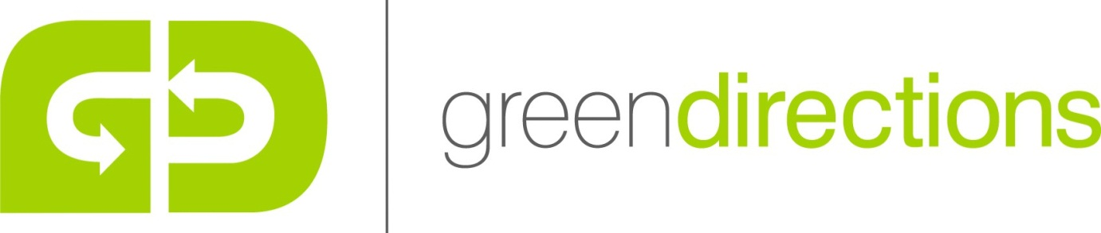

Green Directions Environmental Practices

The walls, floors and roofs of Green Directions buildings are very well insulated with a variety of systems including multi-foil products and phenolic boards. Windows are made of English oak and double glazed.
Our 2 wind turbines and solar panels generate over 40,000 kilowatt hours of electricity per year which is approximately what is needed to run Green Directions. We therefore think of ourselves as being energy neutral.
Heating is provided by ground source heat pumps which efficiently transfers heat from the ground (collected via water pipes underneath our hay field) into our under-floor heating system.
Our electricity production, heat production and insulations systems save around 22 tonnes of CO2 per year.
We have a rainwater re-cycling system. Rainwater is collected from the roofs of the barns and piped into a 12,000 litre tank which is buried and therefore hidden from view.
All crockery, cutlery and glasses are washed not disposed of.
All waste materials are separated and plastic, glass, paper, cardboard and batteries are recycled.
Vegetable waste is composted and re-used on the vegetable plot.
Well-rotted horse manure (from our own horses) is used to re-vitalise the vegetable plot and orchard each year.
Most of the food that we serve is our own produce. Pork and charcuterie from our Tamworth pigs, herbs, vegetables and fruit from our various growing areas.
Other food produce is sourced locally as much as possible.
Drinking water is from our own or the mains supply.
The main business vehicle is a Toyota Aygo – it does around 50 miles per gallon. A Mitsubishi Pajero is used for some tasks such as transporting pigs to and from the farm and for coping with snow.

